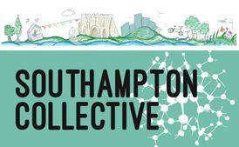
BECOMING A MEMBER OF THE SOUTHAMPTON COLLECTIVE CIC

Membership of The Southampton Collective CIC is open to anyone who:

- Lives or works in Southampton; and
- believes in achieving a healthier, more sustainable and creative city, using the principles of community development (see www.socollective.org.uk/about for more info); and
- is active in their local community, or gives energy to Southampton’s city-wide community in some capacity.

Being a Member means you can get involved in delivering and influencing the direction of our projects.
Members can vote at our Annual General Meeting and other meetings of Members. Decisions are made on a 1 Member, 1 Vote basis, with individual members having the same rights to vote as people who are part of other organisations.

Most decisions on a day-to-day basis are made either by our Board of Directors or the management arrangement for each project. If you are unhappy with a decision or the direction of Southampton Collective you can raise this with our Board and call for a General Meeting of members if you feel necessary or helpful.

These principles are being built into our Governance documents, which are in the process of being reviewed and we will share a draft of these documents for your comments along with our latest Accounts.

Membership is free, but we ask that at meetings, you kindly bring or buy your own drinks (contact us if money is a barrier to attendance). We are a small organisation with limited resources to cover overheads.

Please complete this form if you would like to to be a Member of Southampton Collective, and return to hello@socollective.org.uk. If you have any questions, just ask!

Co-Directors: Rebecca Kinge (tel 07968 777261), Clare Diaper and Mandi Bissett

Name:
Email:
Date:
Signature:

